 | Juan José Cermeño Portet  Valencia, Spain  +34 680 512 665 ∙ jjcerpo@gmail.com  LinkedIn  Personal Details:  June, 19 1977 ∙ Valencia ∙ Spain  Male ∙ Married | 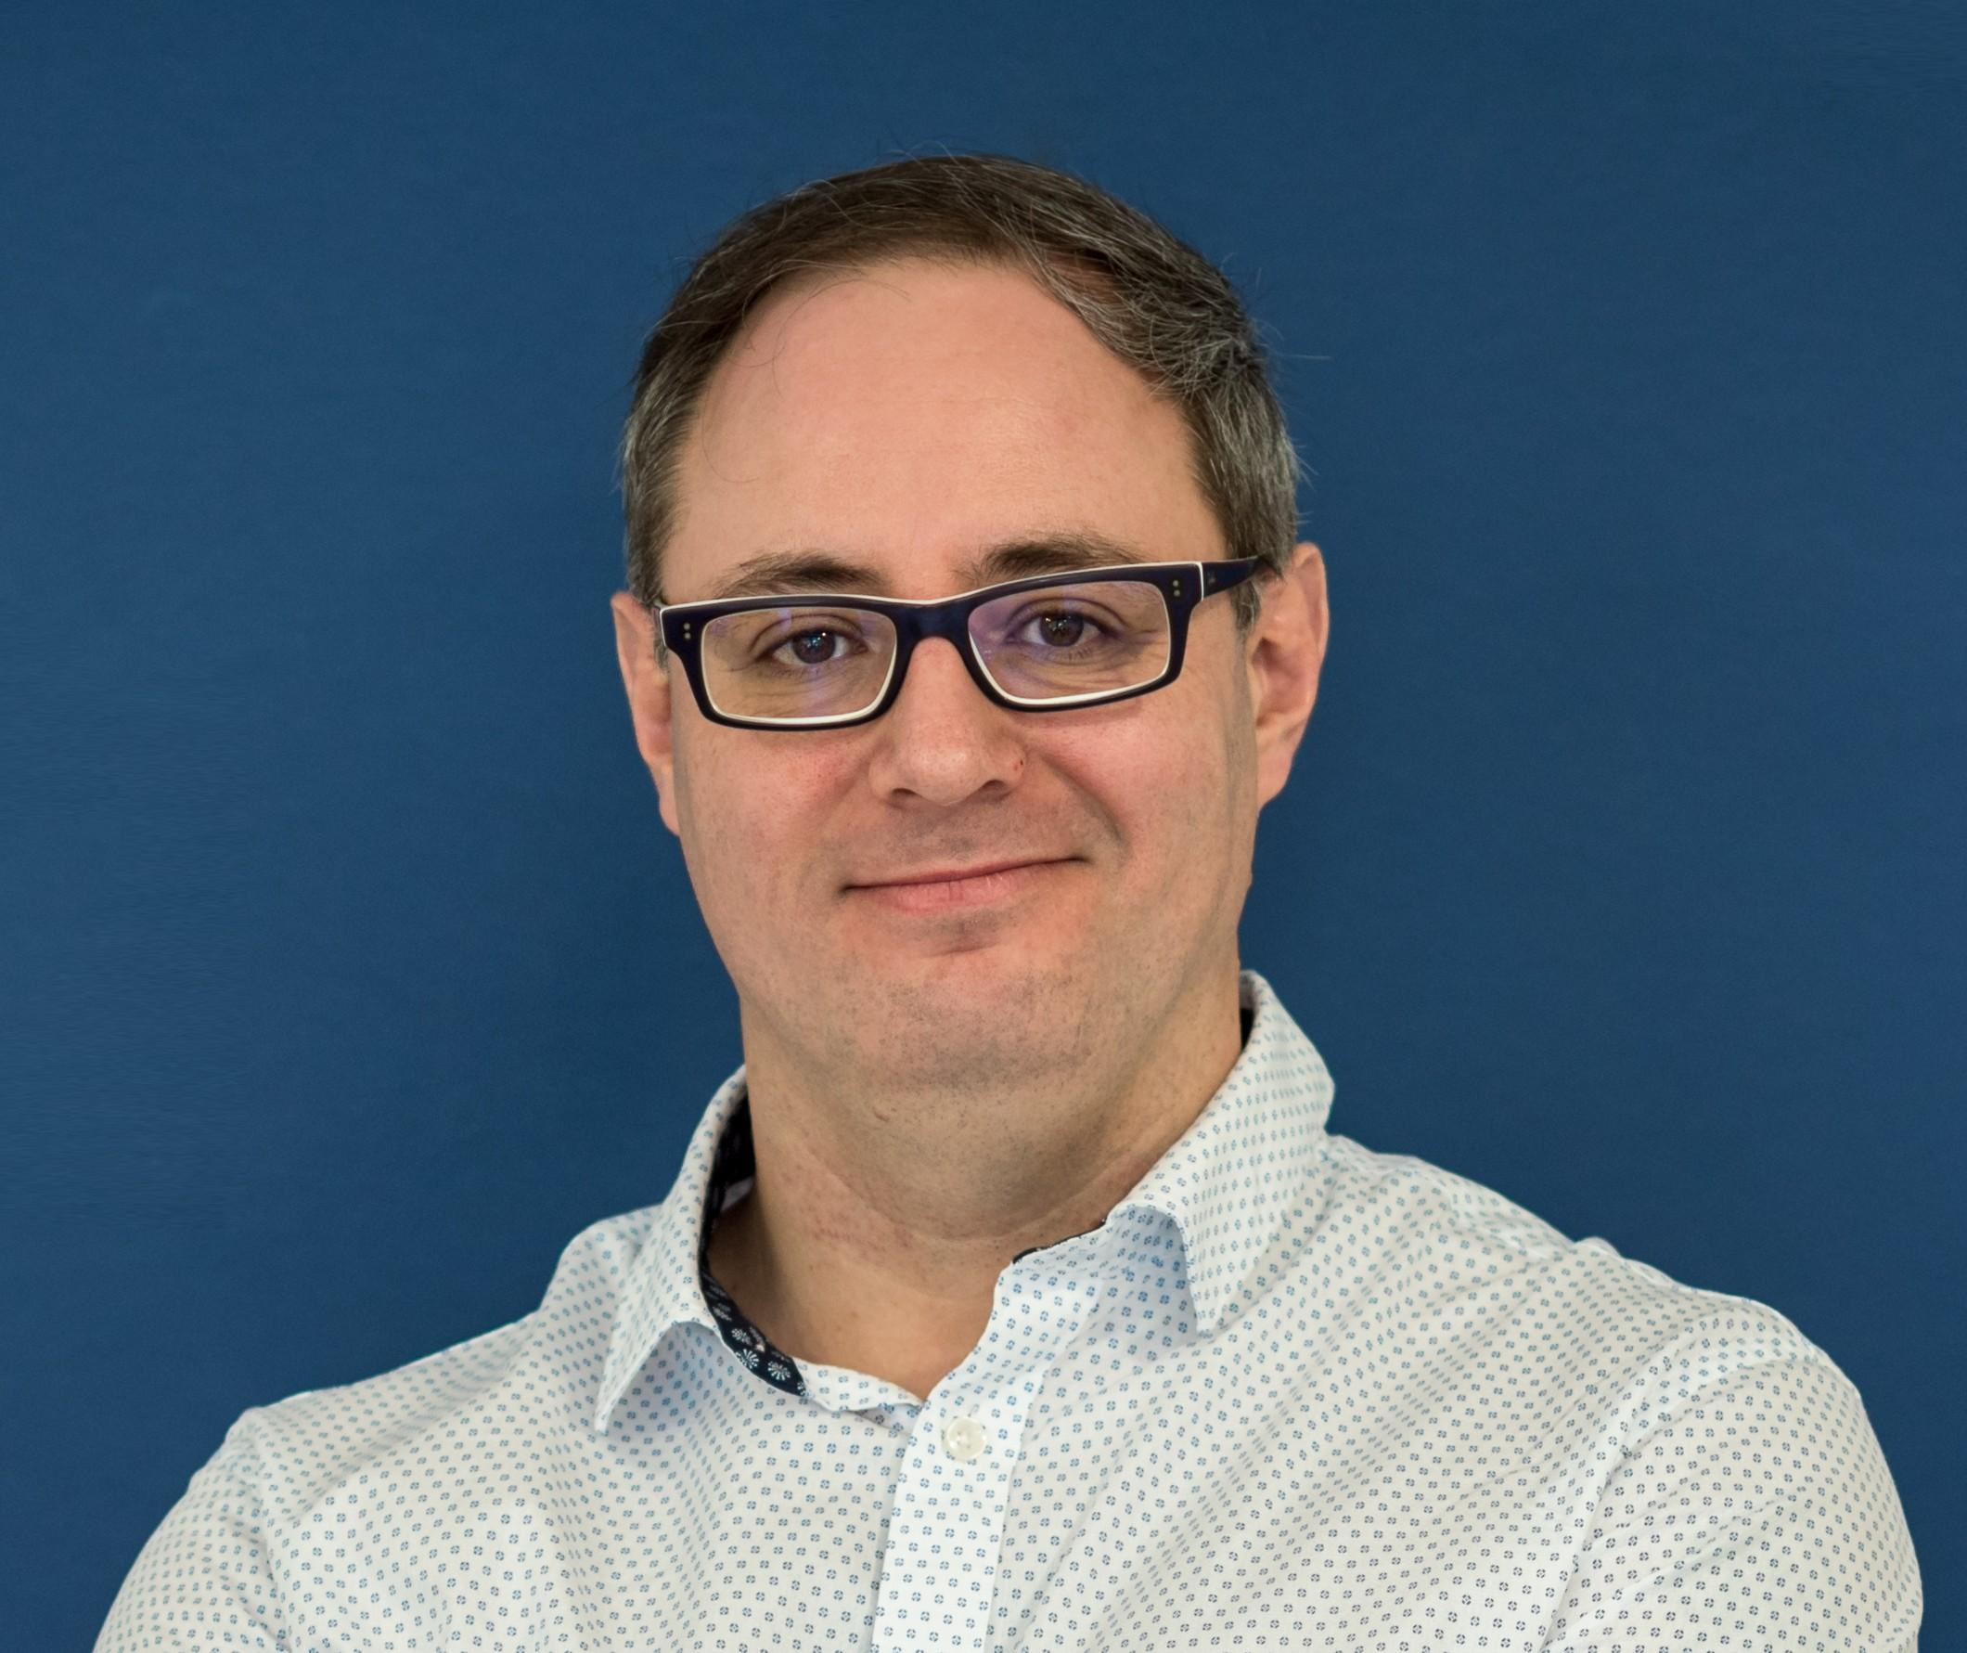

Chief Technology Officer Profile
Project Management – Software Development – Telecommunication Engineer
Programming Languages  Stakeholder Management  Team Leadership & Development  Project Management  Integrated Development Environment  Software Development Life Cycle (SDLC)  Coaching & Mentoring | Analytical, highly adaptable professional with extensive experience designing large systems and managing software projects within various industries.  Skilled in aligning client requirements with business, regulatory, and technological solutions. Possessing 20-year track record of success.  Proficient in crafting creative solutions and talented trouble-shooter continually focused on identifying, isolating, and resolving technical issues.  Personable and strong communicator adept at building and strengthening relationships across functions to drive cohesive, strategic operations.  Intuitive leader directing teams in ever-changing environments through collaboration and transparency.
CAREER ACCOMPLISHMENTS
- Significantly enhanced data structures with completion of two data integrations for Savana Medical while improving team workflow.
- Launched Radiology Information System utilised by radiology professionals for a large hospital and made many customers all around the world.
- Ranked second place for Best Company Project - Valencia City Hall.
- Awarded second prize for Best Science and New Technologies related company - SERVEF (Public Employment Service Valencia).
PROFESSIONAL EXPERIENCE
Savana Medical January 2020 - Present
Data & Integration Engineer (Madrid, Spain)
Lead remote team of developers in creation of framework and modifying communication and shared knowledge. Accumulate, transform, and integrate structured and unstructured data and deliver to a data warehouse. Develop and maintain large-scale data processing system.
- Project Management: Identify undocumented and unshared knowledge as well as duplicate client documentation. Directed team of developers utilising SCRUM methodology to centralise documentation system, check data, and validate protocols.
Ninety Nine March 2019 – October 2019
Senior Ruby on Rails Backend Developer (Madrid, Spain)
Streamlined processes to improve documentation and communication within development team. Defined and implemented application and systems architecture. Developed code for universal data formatter that included currencies, dates, and numbers used in mobile apps. Tested performance, responsiveness, and security of applications.
- Kotlin: Created service, using Kotlin programming language, that enables scanning of worldwide databases to run criminal checks on individuals.
Esoft Creative March 2017 – February 2019
Ruby on Rails Backend Developer (Barcelona, Spain – Odense, Denmark)
Collaborated with project manager, two front end developers, and two back end developers on innovative online marketing tool with integration with ads networks and Facebook designed for use by real estate agencies.
- High-level Programming: Developed web applications and created backend components. Conducted full troubleshooting through verification, isolation, correction, and prevention.
Alfatec Sistemas September 2015 – March 2017
Medical Imaging Division Manager (Valencia, Spain)
Oversaw new Medical Imaging Division in delivering requirement assessment, analysis, design, implementation, maintenance, and technical support projects. Formed marketing strategy to branch out into Latin America and Middle East regions.
- Team Management: Efficaciously deployed software for a large hospital. Defined departmental goals and monitored individual and overall performance. Encouraged teamwork and effective communication.
Sistemas de Imagen Médica Avanzada, S.L. December 2012 – February 2020
Managing Director (Valencia, Spain)
Directed company’s overall growth and functioned as Chief Technology Officer by outlining company’s technological objection and aligning strategies and resources to reach organizational goals.
- Radiology Information System: Established cloud-based medical imaging platform. Provided high level technical support to boost sales.
Turyon Projects SL March 2010 – December 2017
CEO & Software Engineer (Valencia, Spain)
Led strategy for software programming solutions with development of several medical clinic management software. Consulted with clients to formulate customised solutions for specific technical issues.
- Software Development: Assisted 200 clients with tailor-made software products and services and created valuable software solutions for medical imaging centres still in use today.
Kanteron Systems August 2006 –November 2009
Software Developer (Valencia, Spain)
Managed overall operations and advanced sales strategy by offering technical consultation during sales process. Developed PACS viewers; medical viewer for medical imaging storage systems.
- Sales Management: Secured €50K sale within first year. Successfully sold system for €400K to an IT Manager and Executive Director within second year. Negotiated and demonstrated the system within Latin America region within third year and obtained sale of more than €1M.
Additional experience as Software Developer for AIDO and UPV.
TECHNICAL PROFICIENCIES
Ruby on Rails, SQL, Python, Postgresql, git, Confluence, Jira, Bitbucket, Jenkins, AWS, DevOps tasks, Scrum, Sidekiq, Redis, MongoDB, Postman, DICOM. Worklist, RIS, PACS, Viewers applications, Filemaker, OS X development, Java, OsiriX, DCM4CHEE, HIS, EHR/EMR, HL7
EDUCATION AND CERTIFICATIONS
Universitat Politècnica de València (UPV) ∙ Valencia, Spain
Master's Degree, Telecommunications Engineering

Big Data: business strategy and Data Science Fundamentals (80h)
Telecommunications Engineering Official Club

SCIENTIFIC PUBLICATIONS
2003 ∙ Baltimore, USA, ICME
A multimedia Telemedicine system to assess musculoskeletal disorders
200 ∙ Dortmund, Germany, 28th Euromicro Conference
MFMod: a new system for media on demand presentations

